3A 3B
HUMAN BIOLOGICAL SCIENCE
APPLECROSS SENIOR HIGH SCHOOL

DO NOT WRITE ON TEST PAPER

Choose the best alternative and answer on multiple choice answer sheet.

1. Of the following list of substances that can enter a cell, match the order with the correct mechanism by which they would enter cells: oxygen, water, sodium ions, potassium ions, a bacterium. (Note that sodium ions are more concentrated outside cells than inside; potassium ions
are more concentrated inside cells than outside.)
a) endocytosis, active transport, active transport, facilitated diffusion, exocytosis
b) simple diffusion, osmosis, facilitated diffusion, active transport, exocytosis
c) simple diffusion, osmosis, facilitated diffusion, active transport, endocytosis
d) passive transport, osmosis, simple diffusion, facilitated diffusion, active transport
e) osmosis, simple diffusion, facilitated diffusion, active transport, endocytosis

2. ______ is to eating as __________ is the drinking.
a) Endocytosis; exocytosis
b) Phagocytosis; endocytosis
c) Active transport; diffusion
d) Diffusion; receptor-mediated endocytosis
e) Phagocytosis; pinocytosis

3. Which of the following options would result from the actions of DNA polymerase during DNA replication?
a) Two DNA polymerase molecules act to synthesize a long continuous daughter DNA strand from each parental strand; ligase is not needed.
b) Two DNA polymerase molecules act to synthesize a short segment of daughter DNA strand from each parental strand; ligase is used to connect these short segments of both daughter strands.
c) Two DNA polymerase molecules act to synthesize daughter DNA strands: one via a long
continuous strand that moves in the same direction as the helicase, and a second polymerase
synthesizes short segments of DNA that must be joined by ligase.
d) none of the above

4. Which is true of a codon?
a) It consists of three nucleotides.
b) It may code for the same amino acid as another codon does.
c) It never codes for more than one amino acid.
d) It extends from one end of a tRNA molecule
e) It is the basic unit of the genetic code.

5. Which does NOT represent a difference between RNA and DNA?
a) RNA is single stranded.
b) RNA contains the sugar ribose.
c) RNA utilizes nucleotides in its structure.
d) RNA substitutes thymine for uracil.

In questions 6 and 7 below, a segment of DNA has one strand with the following sequence of bases.
A G C G C A T A G C A A

6) The complementary strand of DNA is
a) U C G C G U A U C G U U
b) T C G C C G A T C G T T
c) T C G C G T A T C G T T
d) T C G C A T T A C A U U

7) The mRNA molecule coded for by the original strand is
a) T C G C G T A T C G T T
b) U C G C G U A U C G U U
c) U A C A T T U C A G G G
d) U C G G C A T T U G G C

8) In a eukaryotic cell, transcription takes place _____.
a) on free ribosomes
b) in the rough endoplasmic reticulum
c) in the cytoplasm
d) in the nucleus

9) Electrophoresis is used to
a) amplify small DNA samples to obtain enough for analysis
b) clone genes
c) match a gene with its function
d) cut DNA into fragments
e) separate fragments of DNA

10. DNA fingerprints used as evidence in a murder trial look something like supermarket bar codes. The pattern of bars in a DNA fingerprint shows
a) the order of genes along particular chromosomes
b) the presence of various-sized fragments of DNA
c) the exact location of a specific gene in a genomic library
d) the presence of dominant or recessive alleles for particular traits
e) the order of bases in a particular gene

11. In recombinant DNA experiments,______ is used to cut pieces of DNA and ______ joins the resulting fragments to form recombinant DNA.
a) a transposon . . . a restriction enzyme
b) a transposon . . . a plasmid
c) DNA ligase . . . a restriction enzyme
d) a plasmid . . . DNA ligase
e) a restriction enzyme . . . DNA ligase

12. Which are arranged in the correct order by size, from largest to smallest?
a) chromosome - gene - nucleotide - codon
b) chromosome - gene - codon - nucleotide
c) codon - chromosome - gene - nucleotide
d) nucleotide - chromosome - gene - codon
e) gene - chromosome - codon – nucleotide
13. Imagine an error occurring during DNA replication in a cell, so that where there is supposed to be a T in one of the genes there is instead a G. What effect will this probably have on the cell?
a) The amino acid sequence of one of its kinds of protein will be completely changed
b) Each of its kinds of protein will contain an incorrect amino acid
c) One of its kinds of protein might contain an incorrect amino acid
d) An amino acid will be missing from one of its kinds of protein
e) An amino acid will be missing from each of its kinds of protein

14. During the process of translation (protein synthesis), ________ matches an mRNA codon with the proper amino acid.
a) DNA polymerase
b) transfer RNA
c) a ribosome
d) messenger RNA
e) DNA ligase

Use the diagram below to assist you in answering questions 15 to 17.

15. Structure A contains a
a) genetic code
b) messenger RNA molecule
c) single nucleotide, only
d) small polysaccharide
e) male gamete

16. Structure B represents
a) a ribosome
b) recombinant DNA
c) transfer RNA
d) a female gamete

17. The technique illustrated in the diagram is known as
a) cloning
b) protein synthesis
c) genetic engineering
d) in vitro fertilization
18. The gene-cutting tools of recombinant DNA technology are
a) helicases
b) DNA ligases
c) DNA vectors
d) plasmids
e) restriction enzymes

19, What is transcription?
a) The modification of a strand of RNA prior to the manufacture of a protein.
b) The manufacture of a strand of RNA complementary to a strand of DNA.
c) The manufacture of a protein based on information carried by RNA.
d) The manufacture of two new DNA double helices that are identical to an old DNA double helix.
e) The manufacture of a new strand of DNA complementary to an old strand of
DNA.

20. What is recombinant DNA?
a) DNA that results from bacterial conjugation.
b) It is an alternate form of DNA that is the product of a mutation.
c) DNA that carries genes from different organisms.
d) DNA that is produced as a result of crossing over.
e) DNA that carries a translocation.

21. In a group of organisms, individuals genetically identical at a particular single gene locus show a variety of phenotypes for the trait. It is reasonable to conclude that the variation in phenotypes for this trait is the result of
a) codominance.
b) polygenic inheritance.
c) environmental influences.
d) multiple alleles at the locus.

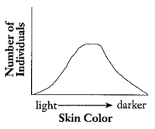
22. Examine the graph below. It illustrates the frequency in types of skin pigmentation in humans. Another human trait that would show a similar inheritance pattern and frequency of distribution is _____.

a) number of fingers and toes
b) blood type
c) incidence of cystic fibrosis
d) height

23. __________ cause the phenotypes of both homozygotes to be produced in heterozygous individuals.
a) codominant alleles
b) environmental influences
c) incomplete dominances
d) mutations

24. In the Australian sheep blowﬂy, the length of the wing is a polygenic trait. This means that
a) there is a small number of clearly deﬁned phenotypes.
b) wing length is controlled by one gene with many alleles.
c) the wing length phenotype shows continuous variation.
d) the phenotype is controlled by many genes on the same chromosome.

25. Translation of the genetic code occurs in the cytoplasm of a cell. The following diagram is one representation of translation.

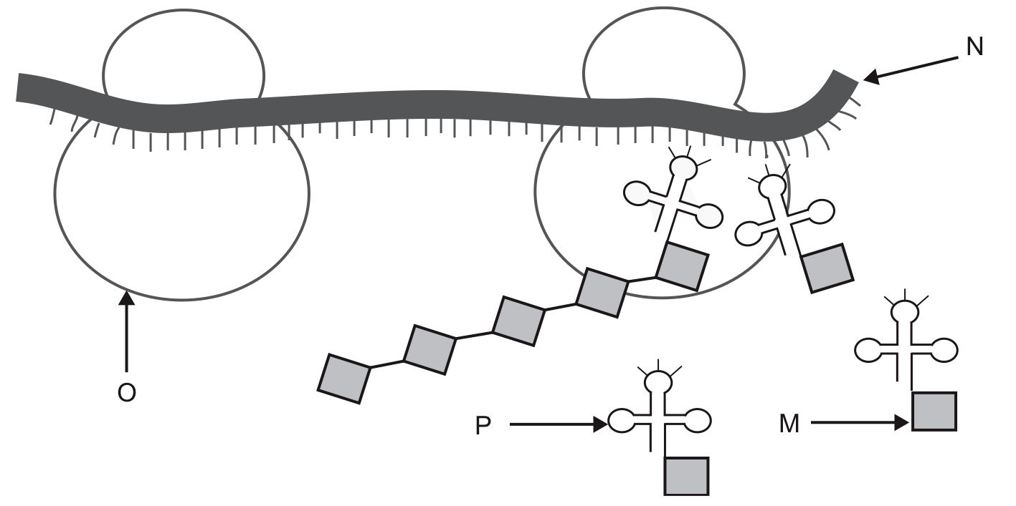
In the model presented
a) M represents a ribosome.
b) N represents messenger RNA.
c) O represents transfer RNA.
d) P represents an amino acid.

26. Ampliﬁcation of DNA in the polymerase chain reaction requires
a) nucleotides of uracil.
b) DNA polymerase.
c) amino acids.
d) ribose sugar.

27. The plasma membrane of a cell
a) is inﬂexible due to the presence of protein molecules.
b) allows substances to pass through only by active transport.
c) contains cholesterol molecules which can act as cell receptors.
d) is relatively impermeable to large water-soluble molecules due to the presence of the bilipid layer.

28. A hormone circulating in the bloodstream would most likely bind to __________.
a) a recognition protein on the cell membrane
b) a receptor protein on the cell membrane
c) protein filaments in the cytoplasm
d) a channel protein on the cell membrane
29. Substances are able to cross the lipid bilayer of a cell at different rates that are unique for each
substance. Which of the following characteristics would favor the simple diffusion of a substance
across a cell membrane?
a) small molecule size
b) the number of membrane transport proteins for the substance
c) small concentration gradients
d) low lipid solubility

30. Recognition proteins function to __________.
a) bind hormones and alter the intracellular physiology of a cell
b) regulate the movement of ions across the cell membrane
c) permit the cells of the immune system to distinguish between disease causing organsisms such as bacteria and cells of your own body
d) all of the above

31. Which one of the following processes does NOT take place in the nucleus?
a) replication of DNA
b) translation
c) assembly of ribosomes
d) removal of introns from RNA
e) transcription

32. Which summary of protein synthesis is correct?
a) DNA transposons leave the nucleus, go to a ribosome, and catalyze the polymerization of amino acids in a protein.
b) DNA exchanges its thymine units with uracil in polymerase. This activates polymerase, and it starts joining amino acids together.
c) Transfer RNAs line up on a ribosome, and amino acids bind to them with hydrogen bonds.
d) Messenger RNA is made on a DNA template, and then amino-acid-bearing transfer RNAs line up on it in through codon-anticodon pairing.

33. In a group of organisms, individuals genetically identical at a particular single gene locus show a variety of phenotypes for the trait. It is reasonable to conclude that the variation in phenotypes for this trait is the result of
a) codominance.
b) polygenic inheritance.
c) environmental influences.
d) multiple alleles at the locus.

34. A particular ____ carry the information for making a particular polypeptide, but ____ can be used to make any polypeptide
a) gene and ribosome ... tRNA and mRNA
b) gene and mRNA ... a ribosome and tRNA
c) ribosome and mRNA ... a gene and tRNA
d) gene and tRNA ... a ribosome and mRNA
e) tRNA and ribosome ... a gene and mRNA

35. The diagram shows portion of a cell engaged in protein synthesis. The various parts of the cell are
not drawn to scale.
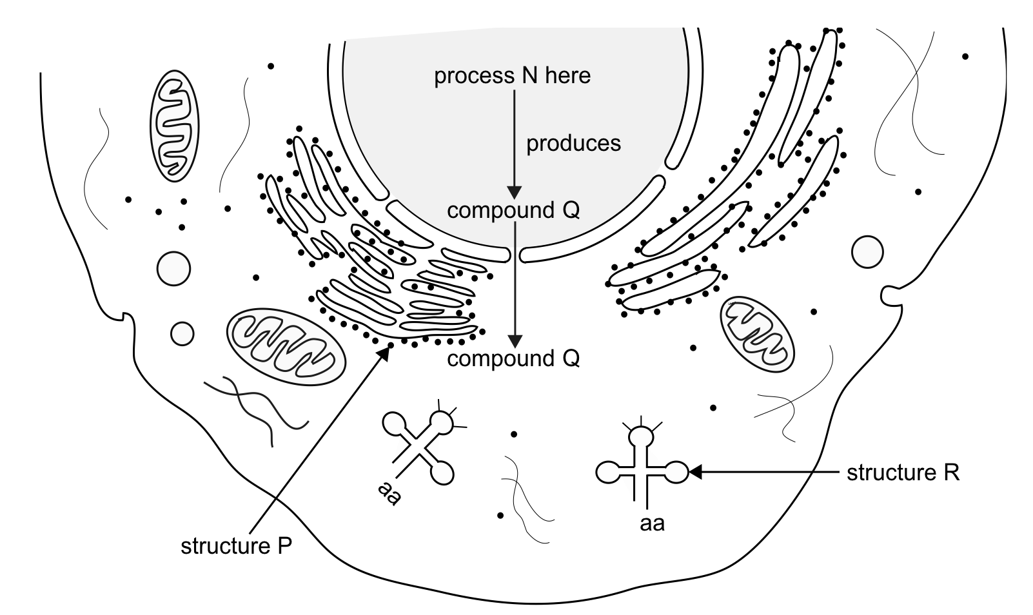

It is reasonable to conclude that
a) process N is translation.
b) structure P is made of t-RNA.
c) compound Q is messenger RNA.
d) structure R is the site of protein synthesis.

